### **Lecture 139. AWS ECS Lecture Needs Updating (2023-02-01)**

<https://www.udemy.com/course/docker-kubernetes-the-practical-guide/learn/lecture/22626539#questions/19146302>

4 upvotes**4**

[Felix](https://www.udemy.com/user/felix-flores-34/) ·

Lecture 139

 · 12 days ago

It took me 4 days to sort through the 14 minute lecture but I finally got my set up working. The UI for AWS ECS has changed and therefore the steps are a bit different.  
  
After you click getting started go to "Task Definitions" first

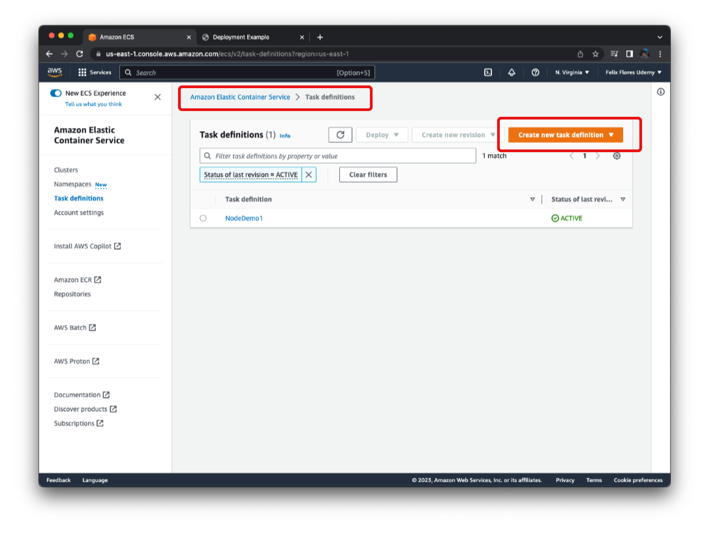

Then click "Create a new task definition".  After this, the instructions for setting up the container mostly matches what he goes over on the video. Follow his instructions until you finish setting up the task.

Pause the video. Then do this.  
  
Once you set up the task you can navigate into it and click the checkbox next to it and select the deploy drop down.

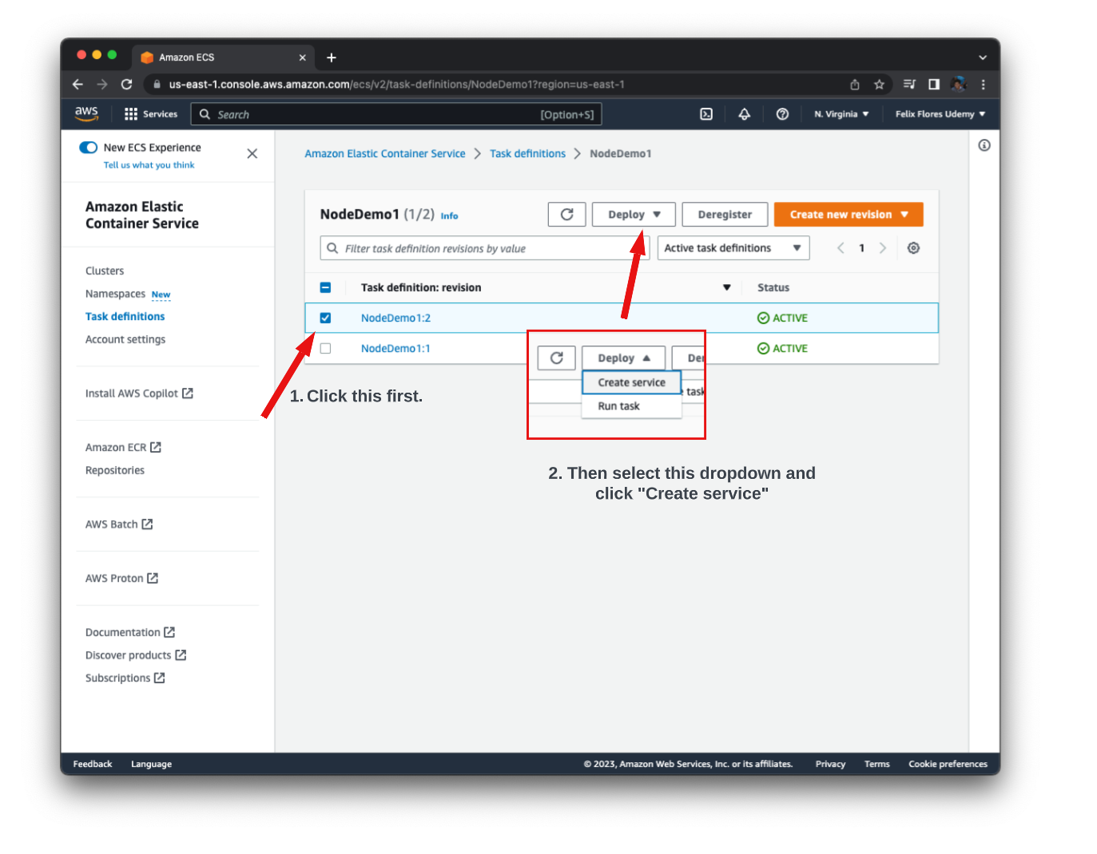

Then you can follow along the video again to provision the cluster.  Once that's done you should see something like this under the clusters section.

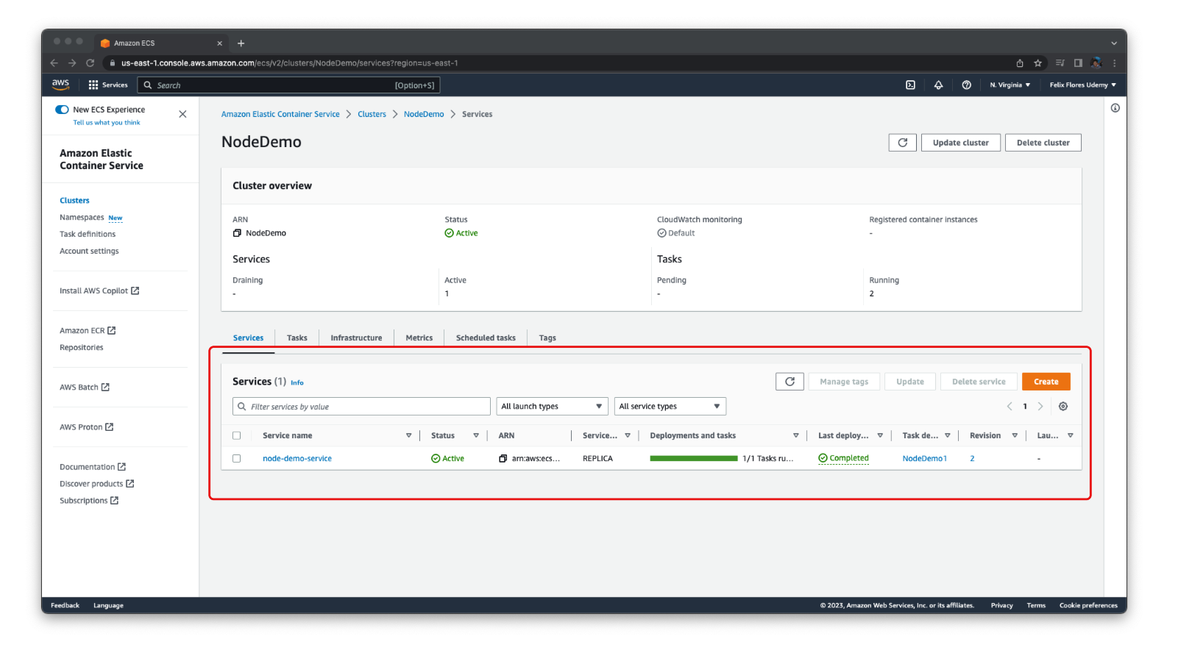

You notice that if you follow his steps and attempt to navigate into it, you'll get a timeout. This is because by default, the public IP does not expose port 80 to the public. To fix this you'll need to update the security group settings. To do this click into the service, and navigate to Networking and click the security group link.

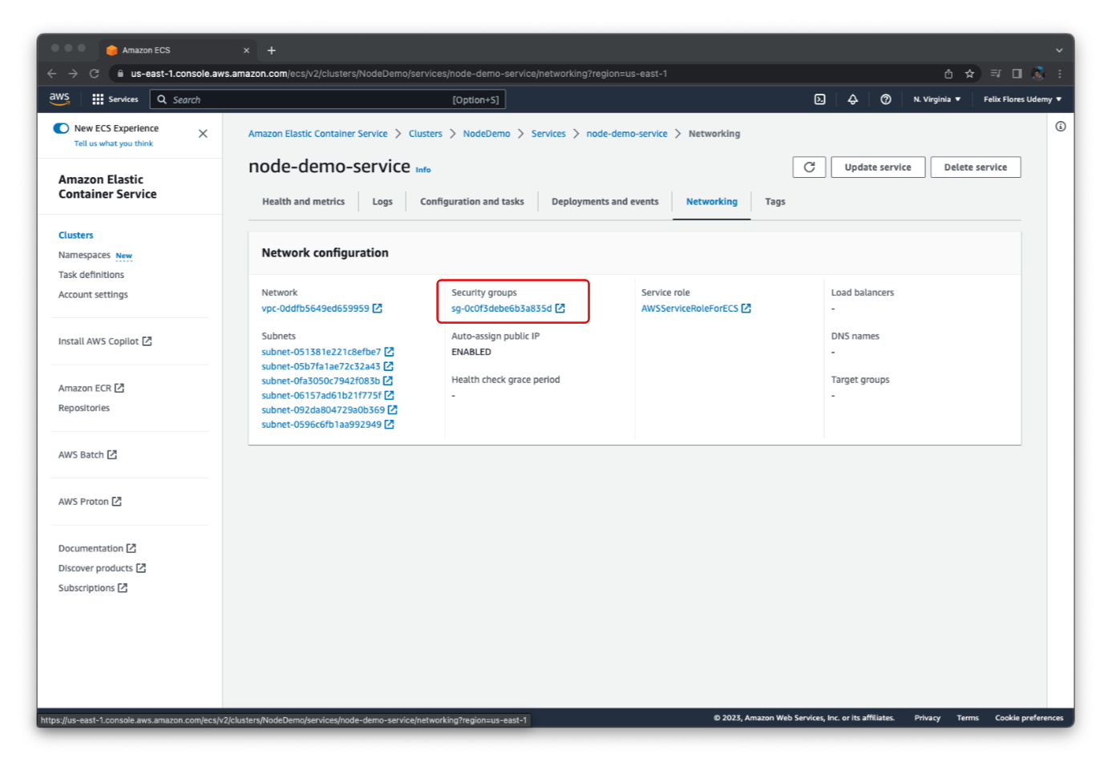

Then you can edit the inbound rules to be like this. This should allow you to connect to the container now!

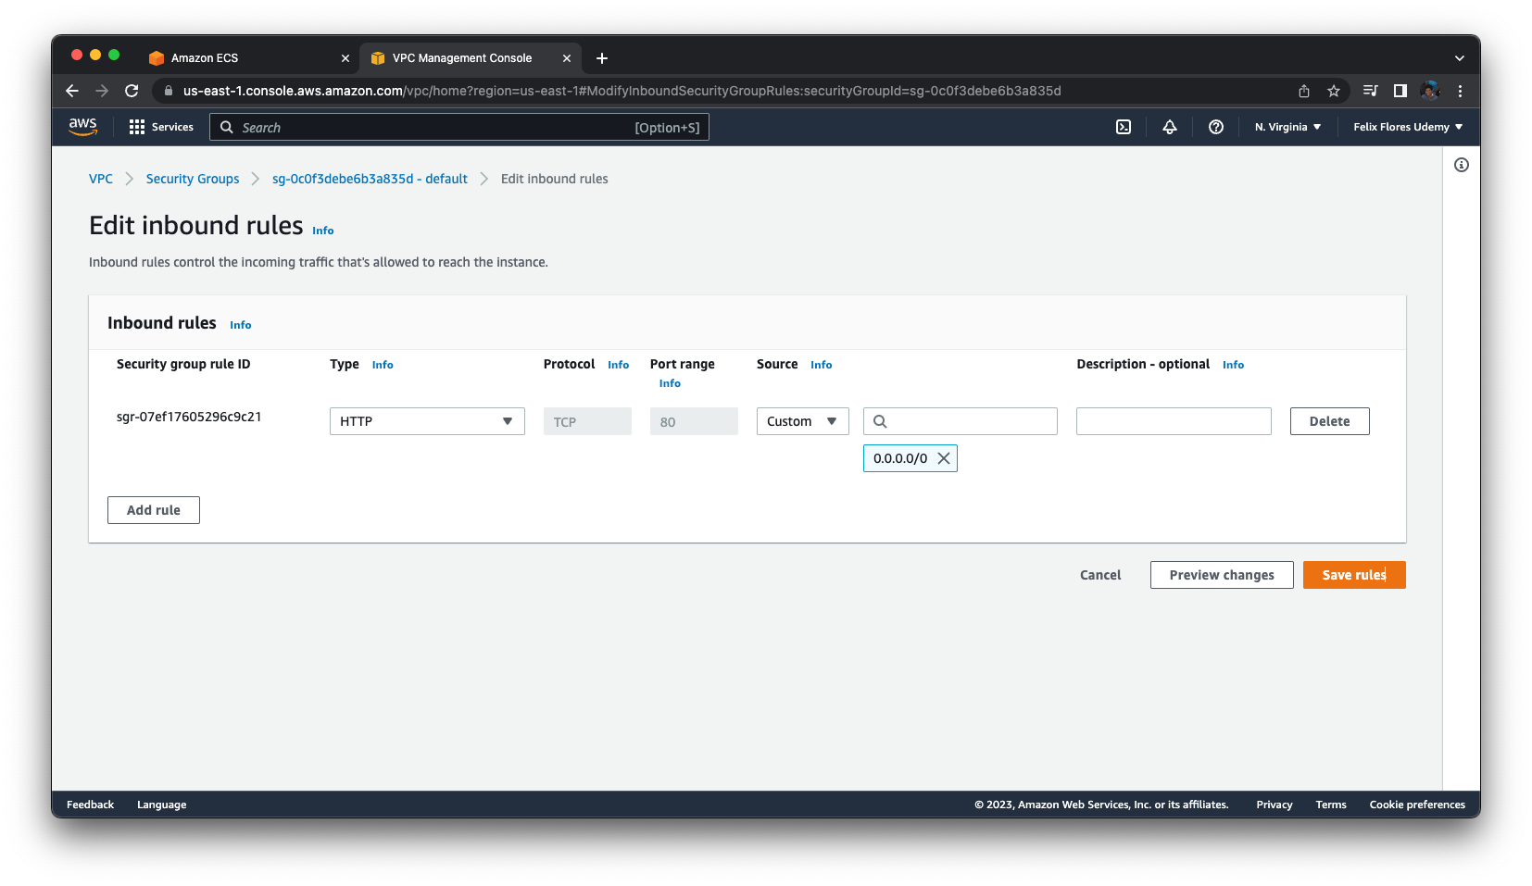

I hope this saves someone a lot of headaches... haha. I know it took me a lot of digging to figure it out.